We  are working towards a normalised approach and assistance for all who have a parent with mental illness.  For more information ring Paul McKillop  Phone / Fax  (03) 9889 3095  Ask about dates for our next Evening Discussion Group, or Weekend Discussion Group / Camps. | Contacts  Victoria:  Convenor: Paul McKillop  Phone (03) 9889 3095  or mail:  NNAAMI  P.O. Box 213  Glen Iris,  Vic, Australia, 3146  Please Enclose a Stamped Self Addressed Envelope  or  Email: via website nnaami.org  or  Internet Page:  www.nnaami.org  Registered Charity  Donations Welcome  Tax Deductible  For more information telephone  Phone / Fax (03) 9889 3095  “We are the children breaking the silence”  NNAAMI inc. | N . N . A . A . M . I  THE NATIONAL NETWORK OF ADULT AND ADOLESCENT CHILDREN WHO HAVE METNALLY ILL PARENTS  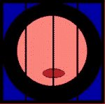  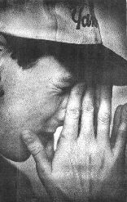  “We are the children breaking the silence”  NNAAMI inc.
NNAAMI
National Network of Adult and
Adolescent Children who have Mentally Ill parent/s

Who are we?  A group of people who have experienced life with a mentally ill parent.  We established our group in May 1995 to provide assistance for one another, via self–help, support, discussion groups and counselling.  We also wish to inform the community and government of our common needs and life experience. | More about us:  Linking people together who have a mentally ill parent.  Advocate for members needs.  Informing the general public and government of our needs.  Services must be fully managed organised and controlled by the affected group, young people and others who have a mentally ill parent.  *  A network growing across Australia & internationally.  A voluntary organisation. | Affected lives:  “Sadness; all my life is sadness.  I can’t cry about it but I’ve got nothing to laugh about.”  - - -  “This is not the sort of thing you tell your school friends or workmates about.  It’s not the sort of thing you tell anyone about really!”  Copyright NNAAMI April 2003

“We are the children breaking the Silence”

